 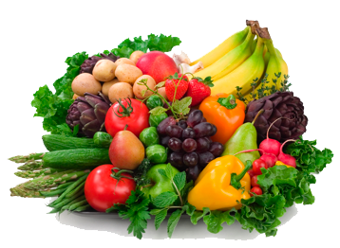 MENU FIRST WEEK BACK IN SEPTEMBER
This Photo by Unknown Author is licensed under CC BY-NC

MONDAY TUESDAY WEDNESDAY THURSDAY FRIDAY
Inset Day | Sausage Roll  OR  Cheese Roll  Oven Baked Wedges  Baked Beans  Sponge or Cora’s Crumble & Custard  OR  Fresh Fruit  OR  Yoghurt | Usual menu | Usual menu | Usual menu

Although nuts are not used in our meals, some may contain traces of nut or nut derivatives.
Please advise the school if your child has special dietary requirements e.g. coeliac.
It may be necessary to change the menu without prior notice. All our poultry and meat is delivered fresh from Dixons Butchers.
v Vegetarian
ve Vegan

