
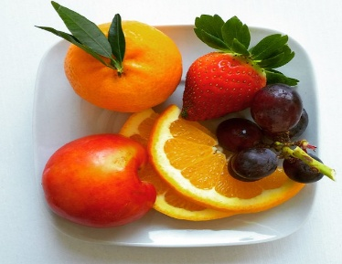M E N U 2
This Photo by Unknown Author is licensed under CC BY-SA
W/C: 7 SEP, 21 SEP, 5 OCT, 19 OCT

MONDAY TUESDAY WEDNESDAY THURSDAY FRIDAY
Sausage Roll  OR  Cheese Roll (v)  Oven Baked Wedges (ve)  Baked Beans (ve)  Frozen Strawberry & Vanilla Mousse  OR  Fresh Fruit (ve)  OR  Yoghurt (v) | Italian Style Pasta Bolognaise (v)  OR  Italian Style Vegetable Pasta Bolognaise  Sweetcorn (ve)  OR  Jacket Potato with Cheese (v) or Tuna Mayonnaise  Sponge/Apple Crumble and Custard (v)  OR  Fresh Fruit (ve)  OR  Yoghurt (v) | Roast Chicken & Yorkshire Pudding  OR  Quorn Sausage & Yorkshire Pudding  Gravy (ve)  Mashed Potato (ve)  Baby Carrots (ve)  Broccoli (ve)  OR  Jacket Potato with Cheese (v)  Ice Cream Tub (v)  OR  Fresh Fruit (ve)  OR  Yoghurt (v) | Summer Brunch Bap  OR  Summer Brunch Bap (v)  Hash Brown (ve)  Baked Beans (ve)  OR  Fresh Fruit (ve)  OR  Yoghurt (v) | Giant Fish Finger & Tomato Ketchup (v)  OR  Homemade Sandwich and Tomato Ketchup  Chips (ve)  Garden Peas (ve)  Oaty Biscuit (ve)  OR  Fresh Fruit (ve)  OR  Yoghurt (ve)
Although nuts are not used in our meals, some may contain traces of nut or nut derivatives.
It may be necessary to change the menu without prior notice. All our poultry and meat is delivered fresh from Dixons Butchers.
Please advise the school if your child has special dietary requirements e.g. coeliac.
v vegetarian ve vegan

